**Lab Report No: 02**

**Name of the lab report: Basic Linux command.**

**Name: MD. Samim Hossain**

**ID: IT-17033**

**Objective:** On linux operating system we can use Terminal for using command line. By using command we can work in Linux. Here we use some Basic Linux Command.

1.pwd -present working directory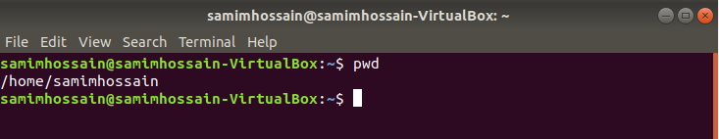

2.cd – This command is use to change directory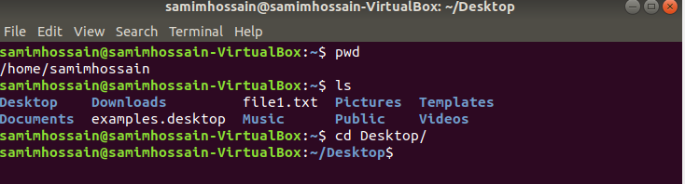

3.cd ~ This command is used to go home directory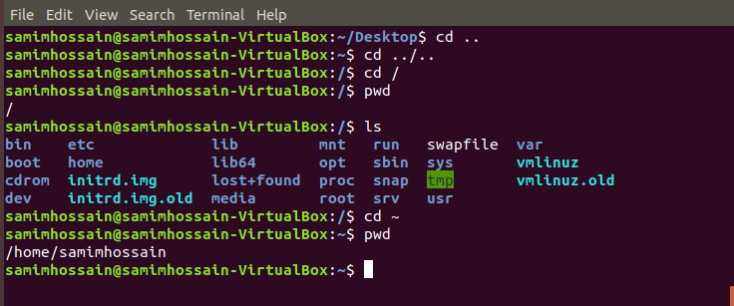

4.cd .. This command is used to back one folder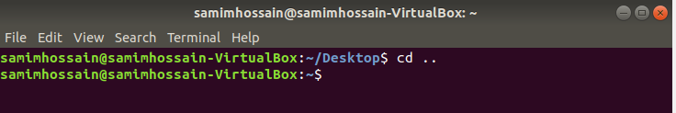

5.cd ../.. This command is use to back two folder

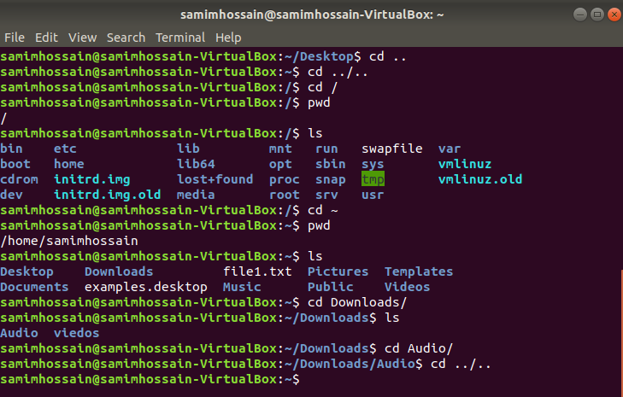

6.ls – This command is use to show all content of present folder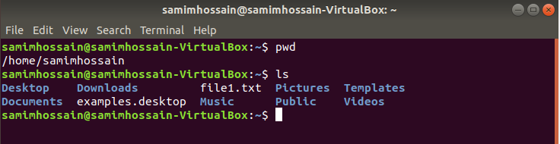

7.ls –a This command is use to display all hidden files content of present folder

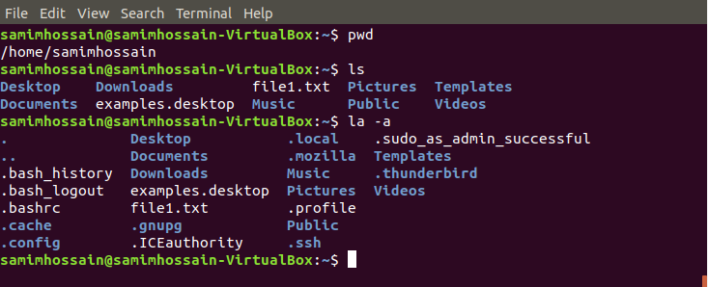

8.ls –al This command is use to display all hidden files in long format.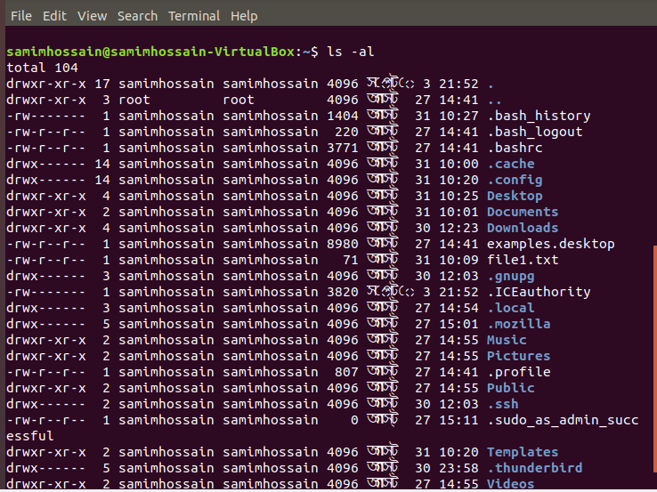

9.man ls –This command is display of all command of ls

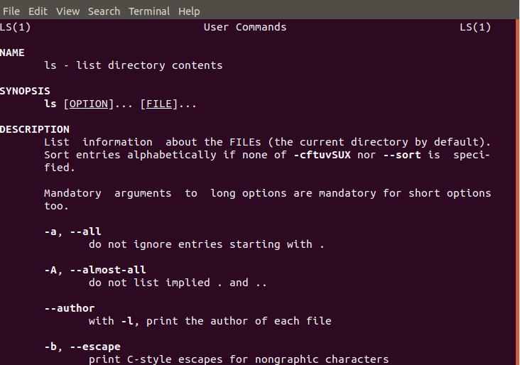

10.uptime –This command is use to display current time

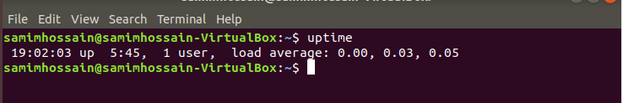

11.sudo command

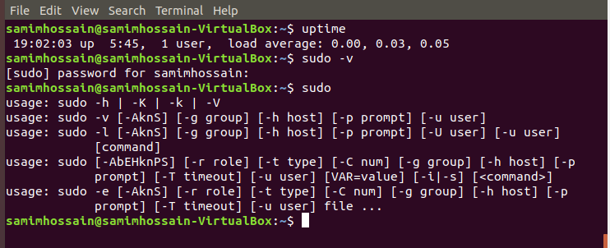

12.passwd –This command is use to change Linux password

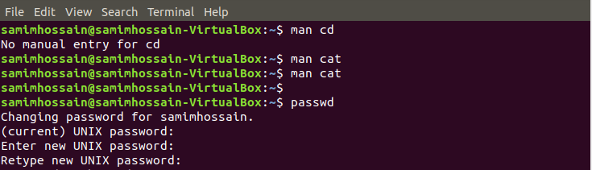

13.hostname –This command is use to show virtualbox hostname

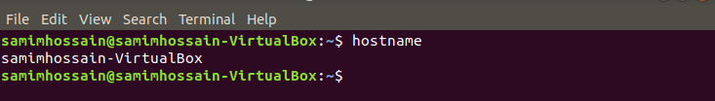

14.rm – This command is use to remove or delete folders

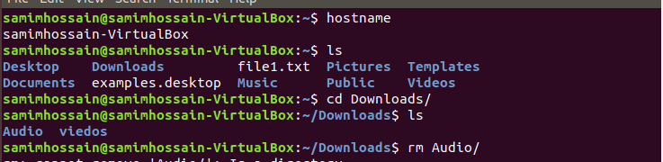

15.chmod –This command is use to Make a file executable

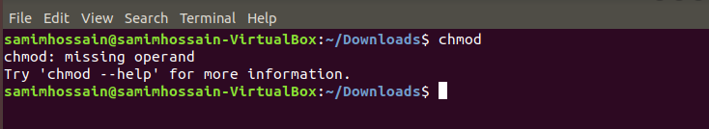

**Conclusion :** Linux is an open source operating system .Here we use some Basic Linux command to work in Linux